HALLOWEEN CARNIVAL
………………………………….
Middle School students will be hosting a Halloween Carnival
October 31st, 1:00-3:00
………………………………....
Come in costume!
  - Costumes must allow easy movement by the child (think about recess time and bathroom!)
  - Please no scary costumes, which includes weapons and props
  - Makeup and masks not allowed
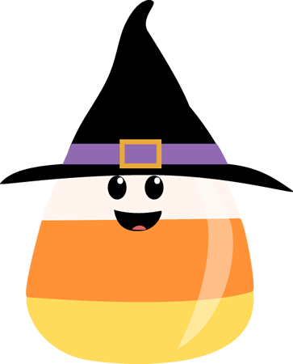
………………………………..
Get ready for some Halloween fun and games!

